Anniversary & Revival Services

April 19th – 21th, 2015
Marion B.C.
(312 W. Wetz St., Marion, TX 78124)

Sunday morning 10:30, Evening 6:00
Monday & Tues 7:00 pm

Evangelist: Brent Carr
Music by Carr Family & Full Quiver Family
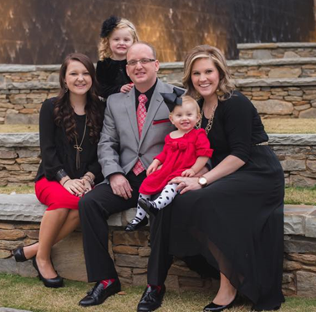
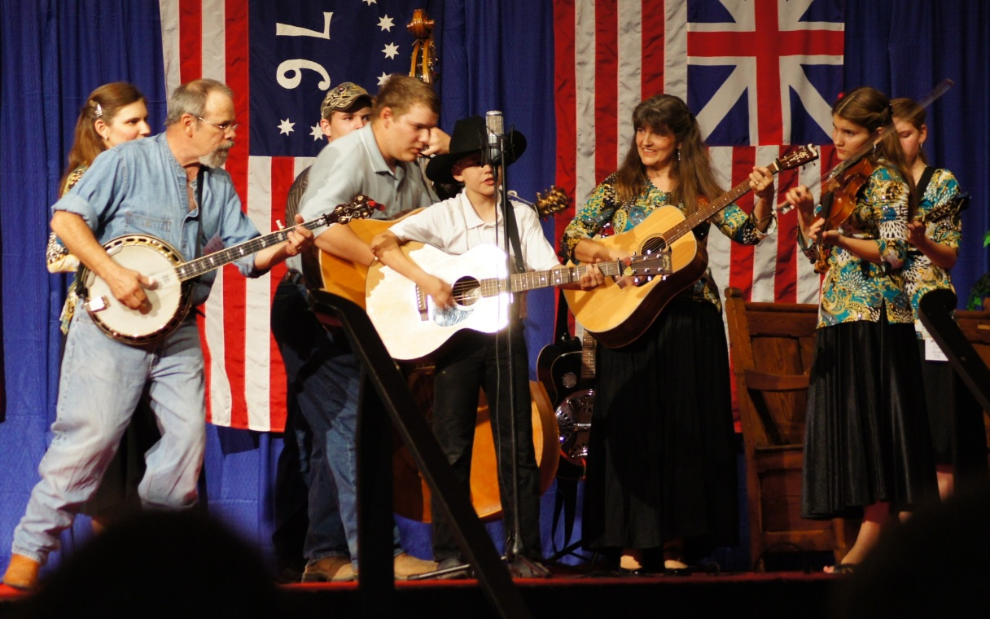

Ps. 95:6 – “O come, let us worship and bow down: let us kneel before the LORD our maker.”

Join us for a meal and fellowship after each evening service.

NURSERY WILL BE AVAILABLE EACH SERVICE

“We have heard the joyful sound Jesus saves, Jesus saves!”

For more information or pick-up, call Pastor Rudy @ 210-937-2673

